**Ubuntu 18.04 + Apache2**

**Prerequisites:**

* **Ubuntu 18.04/20.04**
* **Apchache2 – 2.4.29 ($apache2 -v)**
* **Postgresql v10 (see the separate postgresql note)**
* **Mod_wsgi (v4.7.1) installed from source**

1. Log in to Ubuntu 18.04 as marvin (has sudo privilege – checking by (a) vi /etc/group; (b) getent group sudo; (c) cat /etc/group | grep sudo* )
2. mkdir /var/www/ww-site; cd /var/www/ww-site
3. Create a venv: python3 -m venv venv
4. Source venv/bin/activate
5. sudo mkdir winter-winn
6. sudo chmond 755 winter-winn -R
7. sudo chown :www-data winter-winn
8. cd winter-winn
9. git init; git clone https://github.com/marvinxu99/py_django_pg_winn.git
10. Postgresql created a db named “winn_la_1”
11. pip3 install -r requirements.txt
12. > Python manage.py collectstatic
13. > python manage.py migrate
14. > python manage.py createsuperuser
15. > python manage.py runserver - ensure there are no errors, then CTRL-C exit
16. Define environment variables:   
    sudo vi /ect/apache2/envvars, add the following to the bottom.

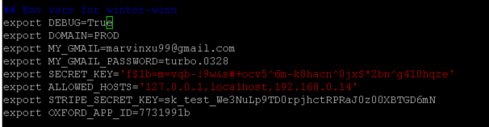

1. cd /etc/apache2/sites-available
2. Sudo cp mysite.conf winter-winn.conf
3. Sudo chown $USER:$USER winter-winn.conf
4. vi winter-winn.conf
5. Ensure the following settings are correct: (in the screenshot, the venv is /var/www/ww-site/venv. Website path is at /var/www/ww-site/winter-winn.
6. 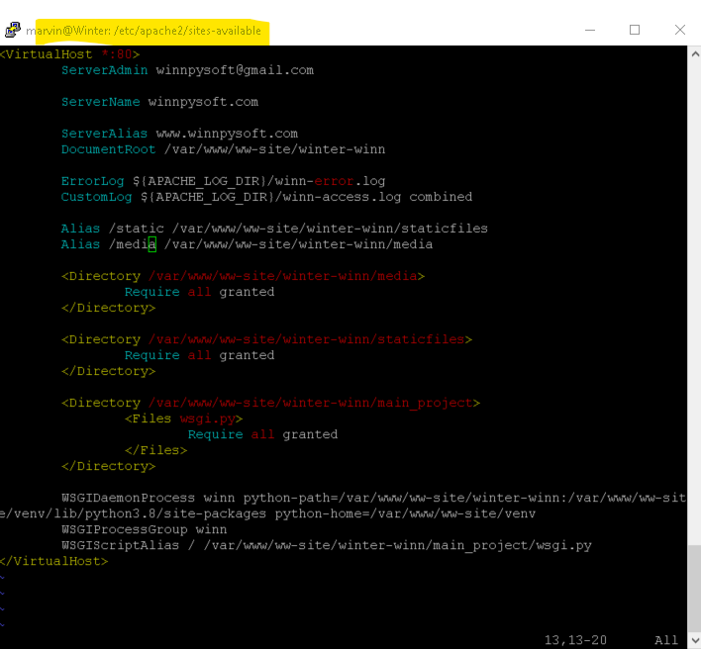
7. Sudo a2ensite winter-winn.conf (if needed, sudo a2dissite mysite.conf)
8. Sudo systemctl reload apache2 ( or sudo service apache2 stop; sudo service apache2 start)
9. Open winnpysoft.com, and ensure media files can be uploaded for iTrac app.pos

Checking the logs:

$ tail -f /var/log/apache2/winn-access.log

$ tail -f /var/log/apache2/winn-error.log

Ensure the following is correct in the /etc/apache2/apache2.conf (for mod_wsgi configure, installed from source)



Ensure in the /etc/postgresql/10/main/pg_hba.conf

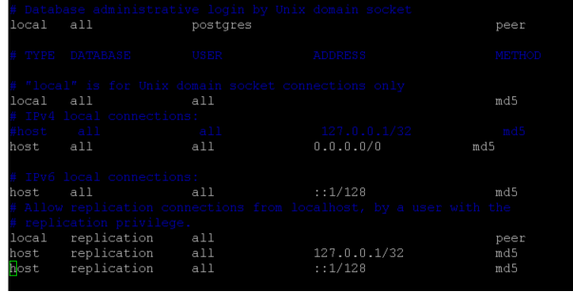

Sudo systemctl restart postgresql